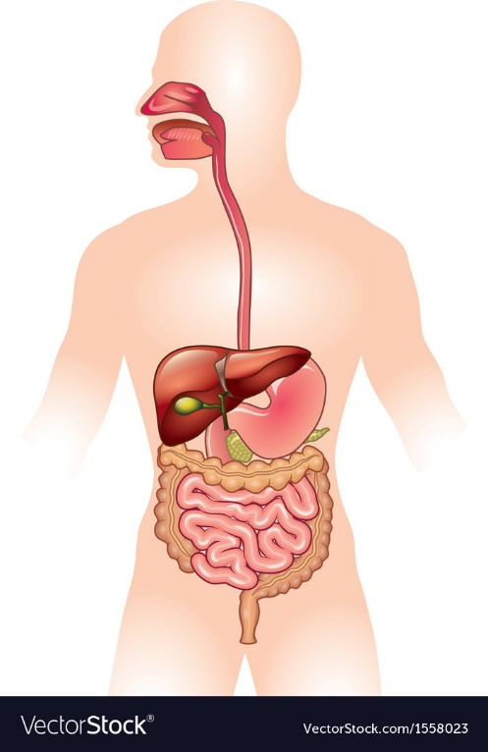
You are to design a ride in a theme park that is based on the organs and processes in the digestive system. The name of your ride can be changed, but the Theme Park is Called “The Big Chew”. The ride must meet the following criteria
- design must be for families! (KEEP IT PG PEOPLE!)
- it must educate as well as entertain
- the ride must allow visitors to experience ALL aspects of the digestive system
- there is plenty of room for creativity still-you can make it based on a water slide, rollercoaster, skateboard park, race track, WHATEVER!
Two Parts: Drawing and Brochure
The Drawing
- You will use the big sheets of paper, trace someone’s body onto the paper and then draw your ride within the outline of your human
- Neat, creative, colored drawing of the rides and 9 points of interest or stops of the ride. Each attraction should be given a name so that it leaves no doubt with what it is (ex: The Stomach Squeeze, The Large Intestine Loop, Pancreas Picnic.
- The ride must flow in logical sequence (mouth to rectum)
- There are some accessory organs that are part of digestion, but not part of the long tube (pancreas, gall bladder, liver, kidneys)
The Brochure
- An explanation of each part of the ride and why you made it the way you did
- All the words must be included in your explanation of your ride/digestion

HAVE FUN!
Mechanical digestion | Chemical Digestion | Mouth
Teeth | Saliva | Esophagus
Epiglottis | Peristalsis | Mucus
Stomach | Bolus | Small Intestine
Liver | Villi or Microvilli | Blood vessels or blood stream
Large intestine | Rectum | Appendix
Bacteria | Nutritens | Duodenum

